**CHAPTER FOUR**

**IMPEMENTATION AND SYSTEM REVIEW**

**4.1 SYSTEM IMPLEMENTATION**

System implementation is the development, installation and testing of system component and the delivery of that system into production. It includes deciding how an information should be constructed (physical system design), ensuring that the information system is operational and also ensuring that the informational system complies with quality standards (i.e. quality assurance).

The system reduces treatment costs by providing an initial diagnosis in time. Patients can detect their heart condition using our computer-aided system or website. Using the proposed system, anyone can checkup their heart condition daily without the cost of enormous money and time. Section 4.1 explains a detailed explanation of our manual checkup system, and 4.2 explain the proposed system's web-based checking procedures.

# 4.2 SOFTWARE DEVELOPMENT TOOLS

The computer-aided general system is developed with Python IDE of python. This is available in Anaconda navigator. Any patient can know heart condition using a manual diagnosis system. Fig.2 shows how a patient can see his heart condition from the initial to the final step. A patient has to input his data into the system to check their cardiac situation. System’s trained classification models are ready to show output according to provided data. The system will indicate one’s heart is infected or not, and at the same time, they also know the accuracy of their result.

**OUTPUT**

NO

YES

**Fig.2** manual checkup system to detect heart disease

# 4.3 WEB BASED APPLICATION

The proposed method provides a web-based checking system also for patients from home. Fig.3 represents the data flow diagram of the heart disease prediction system. To use the system conveniently, the user must log into the system.

**User Login**

* Registration
* Sign-in

**Heart Disease Prediction System**

**SVM**

* Result
* Accuracy
* Sensitivity
* Specificity
* Precision
* F-measure

**Fig.3** Data Flow diagram of Heart Disease Prediction System.

The proposed system provides a registration and login form for the users. At first, the patient should create a user id to check their disease. Fig.4 shows the parameters of the login and registration form. Fig 5 represents the most relevant 13 parameters of cardiovascular disease. A user will provide some values to the system according to parameters to check their disease. Fig. 6 illustrates the final result of the raised prediction system. The patient can see their heart condition according to machine learning classification methods. Each method shows the accuracy and outcome of that algorithm. Every algorithm will show the exact result but the nearest accuracy.



**Fig.4** Heart Disease Prediction System Sign-In Page

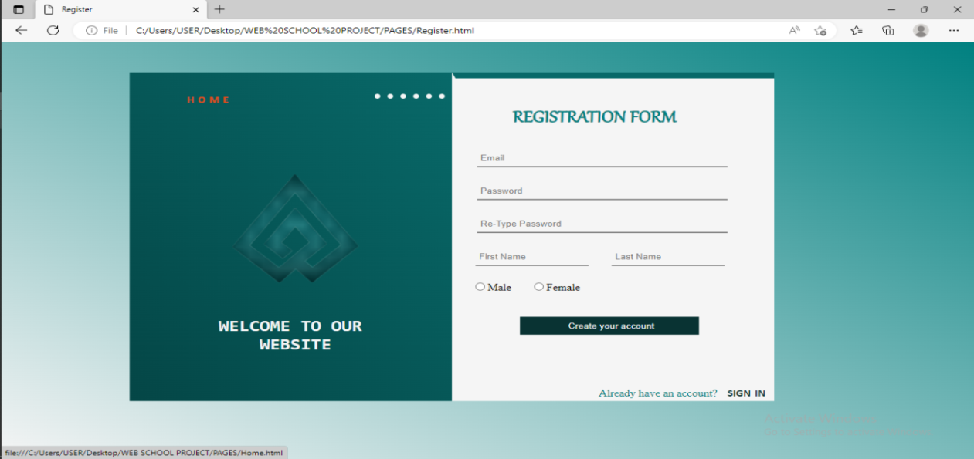

**Fig.4** Heart Disease Prediction System Registration Page

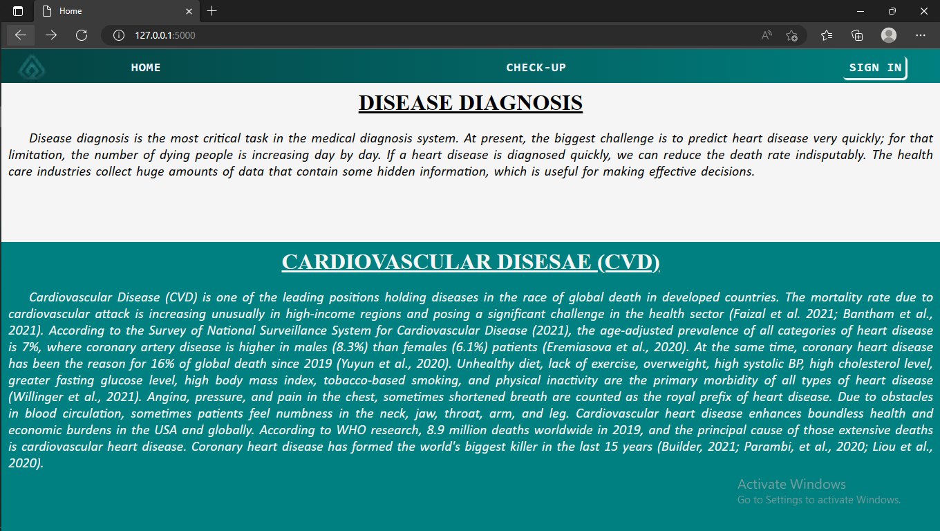

**Fig. 5** Attributes of HDPS (Home and About)

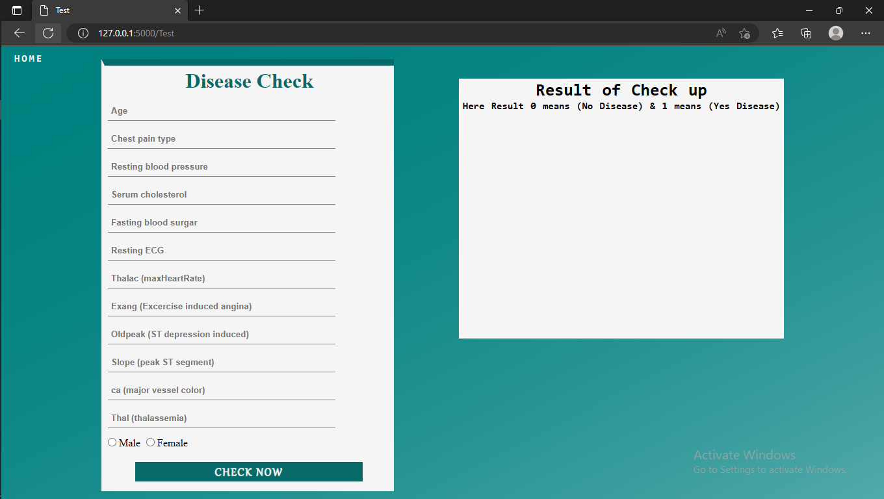

**Fig. 5** Attributes of HDPS (Check-Up and Result page)

**Table 2** Performance matrices equations.

***Metrics***

***Computing equation***

Accuracy

*TP + TN*

*TP + TN + FP + FN*

**(8)**

Sensitivity

*TP*

*TP + FN*

**(9)**

Specificity

*TN*

*TN + FP*

**(10)**

Precision

*TP*

*TP + FP*

**(11)**

F-measure

*2* (Sensitivity + Precision)*

*Sensitivity * Precision*

**(12)**

Classification Error

*FP + FN*

*FP + FN + TP + TN*

**(13)**

**4.4 EXPERIMENTAL RESULTS**

This research has used six measurement schemas like accuracy, sensitivity, specificity, precision, F-measure, and Classification errors to check this system's performance. For calculating six matrices, four several parameters are used. These four parameters are known as True Positive (TP), True Negative (TN), False Positive (FP), and False Negative (FN). Table 2 presents the performance metrics equation. This system has trained on heart disease database and calculated four parameters’ values. Then research computed the six measurement schemas and got traditional values representing the proposed system's performance.

Table 3 shows the accuracy, sensitivity, specificity, precision, F-measure, and classification error of the specified algorithms.

**Table 3** Summary of implemented algorithms performance.

**Models Accuracy Sensitivity Specificity Precision F-measure Classification**

**Error**

**SVM 85 90 82 79 84.14 0.146**

Table.4 narrates the existing methodologies with their taken attributes and accuracies. From 2006 to now, researchers have been trying to predict heart disease with a computer-aided system to reduce time and cost-efficiently.

**Table 4** A comparative studies on various proposed algorithms.

|  |  |  |  |
| --- | --- | --- | --- |
| **Author** | **Proposed Methodology** | **Parameter & Features** | **Accuracy** |
| Alim et al. (2020) | Prediction of heart disease was measured with the help of a support vector machine and kernel equivalent to it  . ***Techniques used:*** Hoeffding tree method | **Not defined** | **86.94%** |
| et al. (2021) Khan | A heart diseases prediction system (HDPS) based on the data mining approaches.  ***Techniques used:*** Naïve Bayes, J48 DT, NN, RF | **14** | **97.70%** |
| Acharya et al.(2015) | A proposed method on heart rate variability signals using data mining techniques where DT provides the highest accuracy.  ***Techniques used:*** Naïve Bayes, KNN, DT | **8** | **92.02%** |
| Dwivedi (2018) | Using an artificial neural network and support vector machine, the proposed method predicts stroke patients where SVM provides the highest accuracy.  ***Techniques used:*** ANN, SVM. | **8** | **85%** |
| Ayon et al. (2020 | Logistic Regression (LR), Support Vector Machine (SVM), Deep Neural Network (DNN), Decision Tree (DT), Nave Bayes (NB), Random Forest (RF), and K-Nearest Neighbor (K-NN) were the seven computational intelligence techniques used.  ***Techniques used:*** DT, RF, NN, Logistic Regression, SVM, Naïve Bayes | **9** | **98.15%** |
| Beyene et al. (2018) | Propose methodology evaluate performance using tenfold cross-validation to predict heart disease. In this method, logistic regression provides the highest accuracy.  ***Techniques used:*** Naïve Bayes, SVM, Classification Tree, Logistic Regression, KNN, ANN | **12** | Not defined |
| Katarya et al. (2020) | Chronic prediction system using data mining techniques where Naïve Bayes, Decision Tree provide the highest accuracy.  ***Techniques used:*** Naïve Bayes, DT, SVM | **10** | **95.56%** |
| Motarwar et al. (2020) | Cardiovascular disease prediction using data mining techniques. Simple Cart provides the highest accuracy.  ***Techniques used:*** Naïve Bayes, J48, Simple CART | **Not defined** | **92.2%** |